PART B

Instance launch failed
You are not authorized to perform this operation. User: arn:aws:iam::548387266019:user/acsad-g08 is not authorized to perform: ec2:RunInstances on resource: arn:aws:ec2:ap-southeast-1:548387266019:instance/* because no identity-based policy allows the ec2:RunInstances action. Encoded authorization failure message: LD-TM4yjzAx5jWQOdM8O62iIHYawrzxUEV1onbmWcjpDx1akBx17cS8D26btsTYVZcQCndyJxtnm5zbPakBhUGq_pRhCdJ-TTBDp4gUO_RiejjpR6ydv5n0LOlFXHIVKTJkmeVIRyRNNkuJxAmybAWUU15r0pI5f53O2TJioXrpttrqLoZNJCDINn1KJAfIRm_Dp81DwXi-9bVTE58opEMJfKoBE29ca4xf2XDxqDK3SirbNjkUrf3B41Vuss-TMQOhhfmjtWSKHM2sDHNM_C4gMXv2vd98zuh30BJr6XkCiei0EeizKwSGbWIdVPm79w7taAHUKxSnAI6tJ26gPLVvS1hCTm7GU7hQ1rMoKb1k0ej4BQxmFbDVRLp6tOmQWx3SOfQ8j9MNOAaciPck8VY5XY4hvx37yU7lX2wV3XIOndQzpxzpKfLb-gqAmmoBnonUKzk4TWby9JRRe9aOgFipWL1hb9uVRqVk3oE32Bevt-Bqi6FhbhCqGRCeaomMxVhOxWiSI9zmasyENkH2Sp9tTmdve5f1evXeRb64ftuzbUDYsJ4NlWpbXfRoF64NbjwXYf15hNN2dA6BiNUxcVvOy-0Yeek0Q1yx9Vk2qBGfHCNXO1bnbuKucEfmbc3cJfzXJZUQ261230yUrOwZ6XOisZQUVW2jGfGPDxCMRMIKle7kjDpfG21bRiv_qwpRbZIqALj-b-kKjSoRCa5iEbAQgur__trQCFEoMs2tD39NFWfyHXw4UHVvD-lzvJS9d6UWmhaWfzq8K0F8l_qV0sjliYksX5Dej8GRkoUJDrGnVAuv4ksdAADM
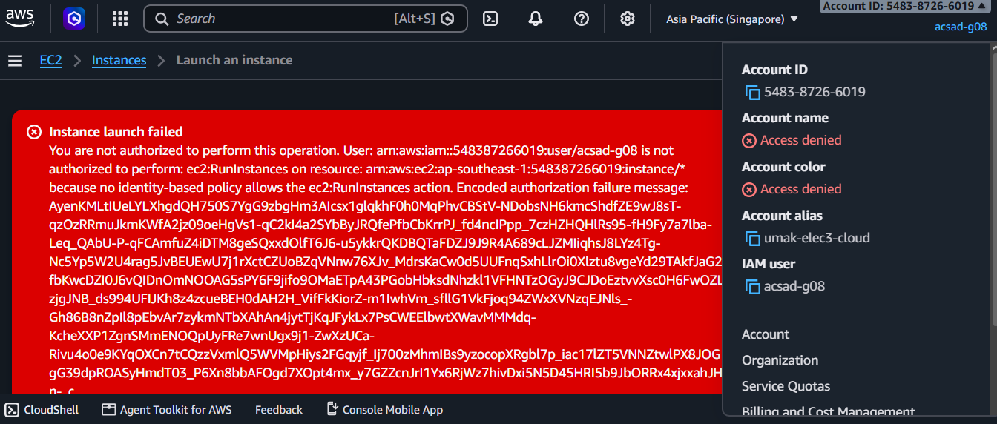
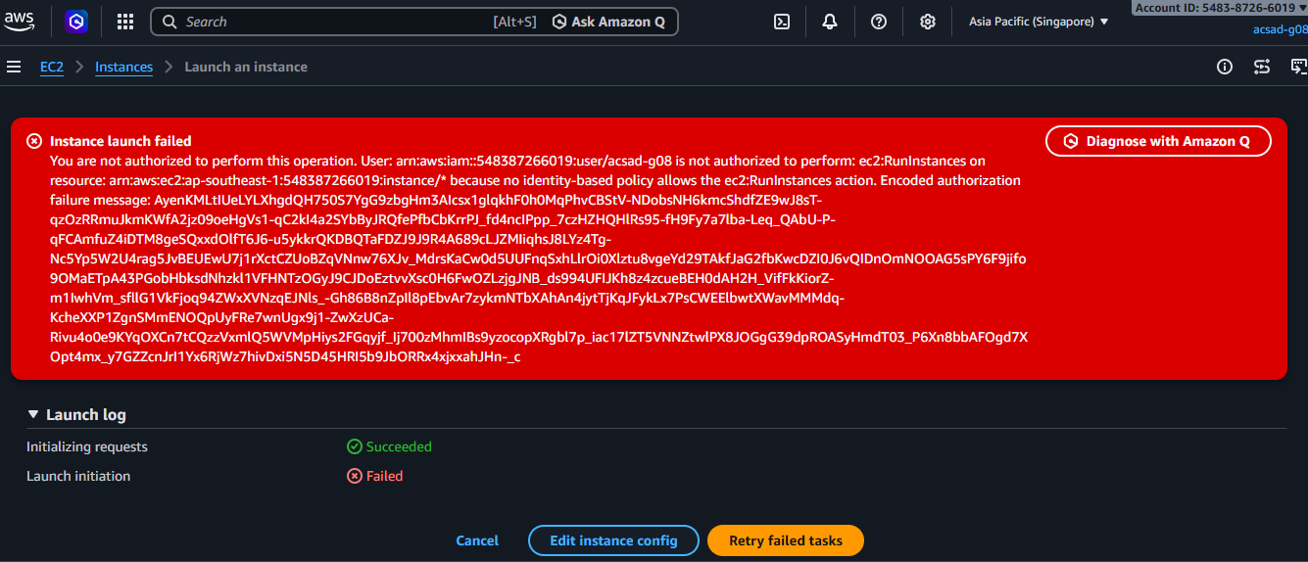

PART C
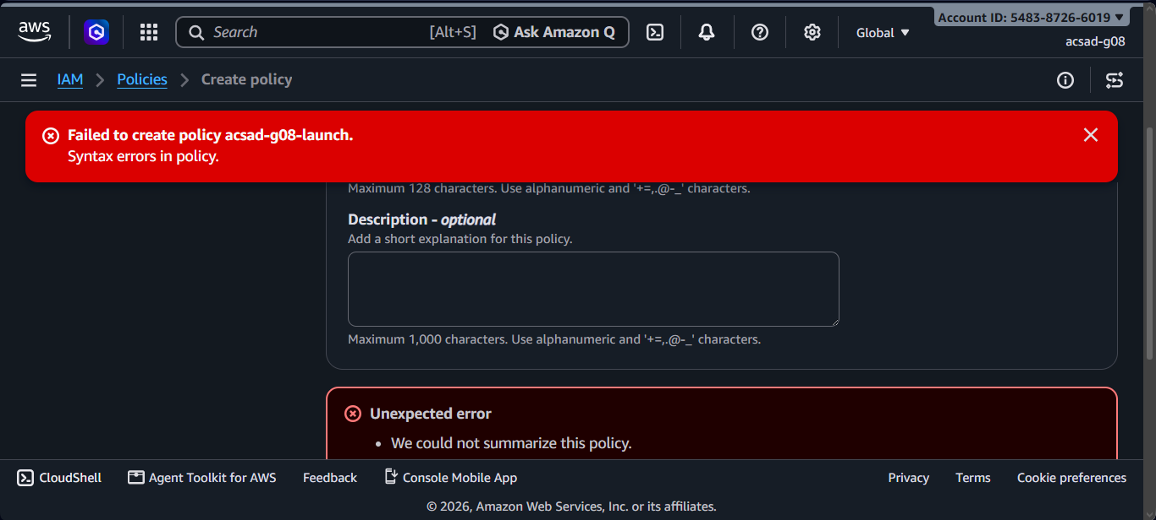
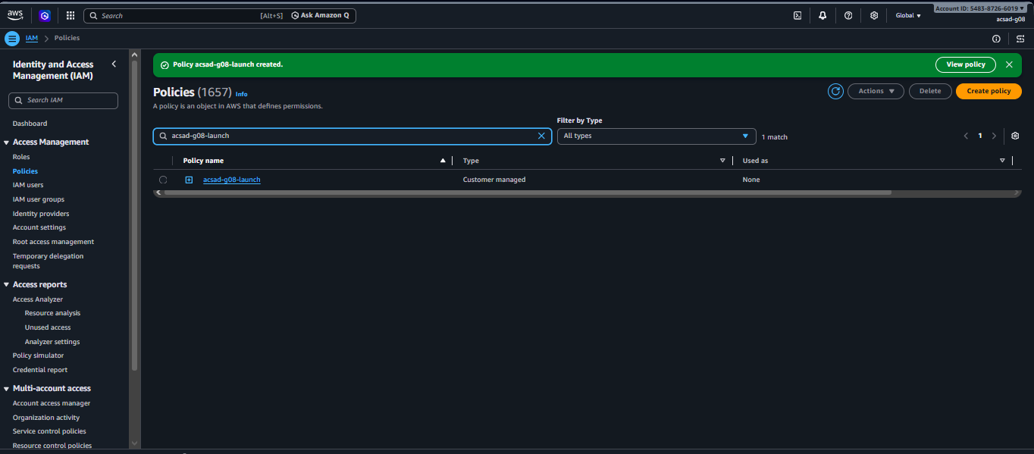
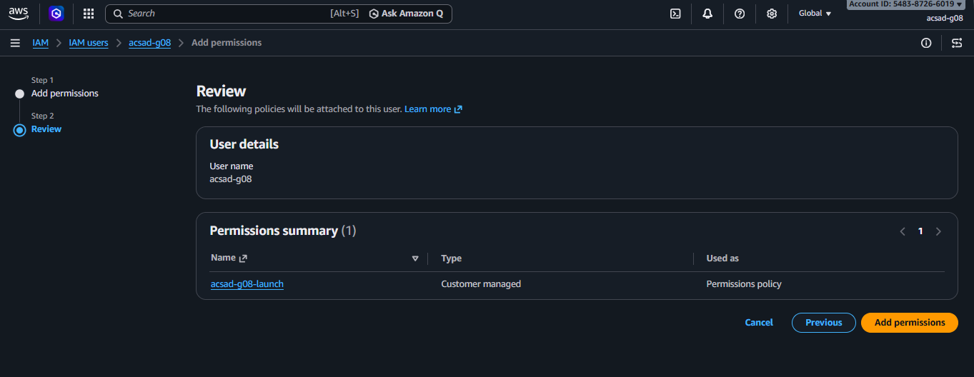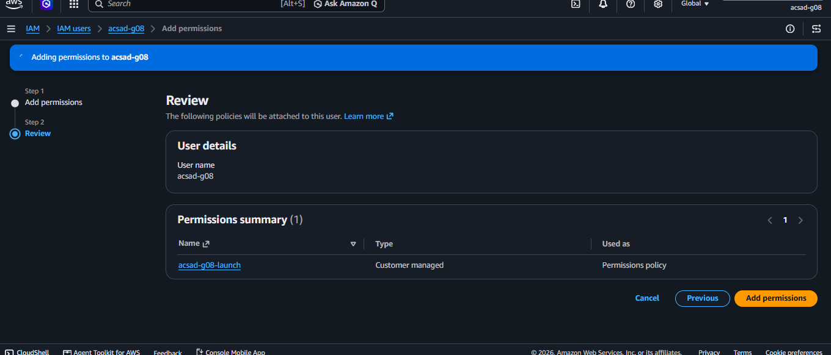

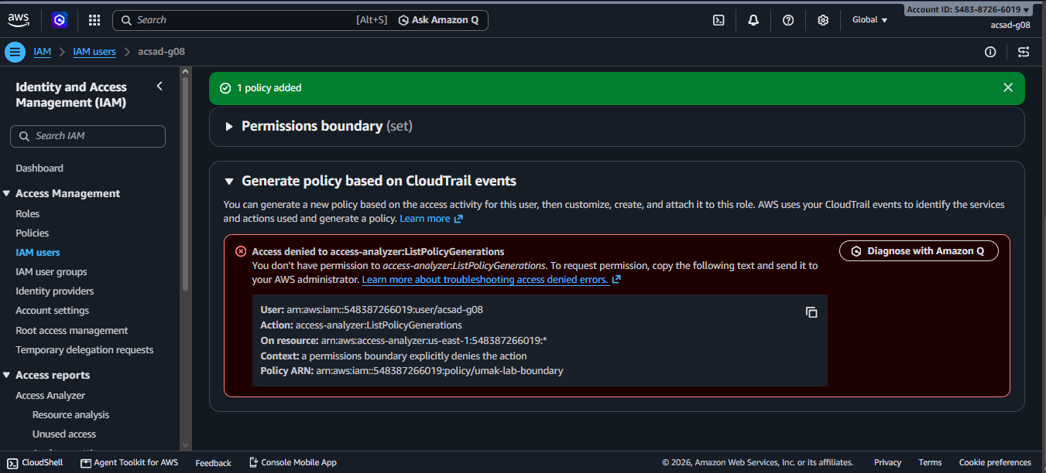PART D
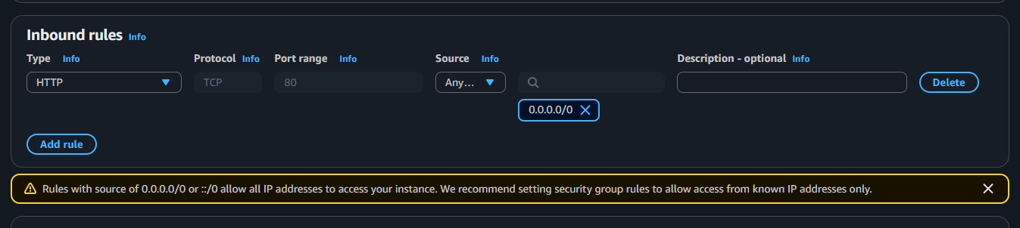
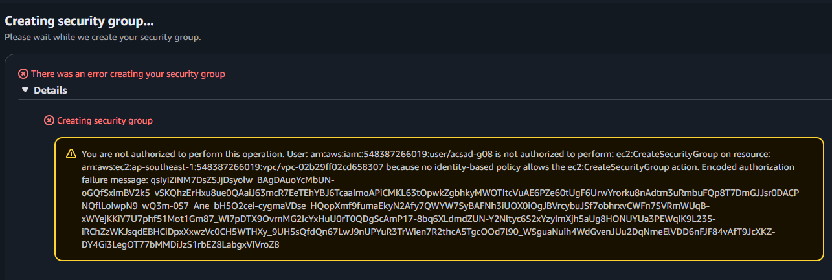
You are not authorized to perform this operation. User: arn:aws:iam::548387266019:user/acsad-g08 is not authorized to perform: ec2:CreateSecurityGroup on resource: arn:aws:ec2:ap-southeast-1:548387266019:vpc/vpc-02b29ff02cd658307 because no identity-based policy allows the ec2:CreateSecurityGroup action. Encoded authorization failure message: qsIyiZiNM7DsZSJjDsyolw_BAgDAuoYcMbUN-oGQfSximBV2k5_vSKQhzErHxu8ue0QAaiJ63mcR7EeTEhYBJ6TcaaImoAPiCMKL63tOpwkZgbhkyMWOTItcVuAE6PZe60tUgF6UrwYrorku8nAdtm3uRmbuFQp8T7DmGJJsr0DACPNQflLoIwpN9_wQ3m-0S7_Ane_bH5O2cei-cygmaVDse_HQopXmf9fumaEkyN2Afy7QWYW7SyBAFNh3iUOX0iOgJBVrcybuJSf7obhrxvCWFn7SVRmWUqB-xWYejKKiY7U7phf51Mot1Gm87_Wl7pDTX9OvrnMG2IcYxHuU0rT0QDgScAmP17-8bq6XLdmdZUN-Y2Nltyc6S2xYzyImXjh5aUg8HONUYUa3PEWqIK9L235-iRChZzWKJsqdEBHCiDpxXxwzVc0CH5WTHXy_9UH5sQfdQn67LwJ9nUPYuR3TrWien7R2thcA5TgcOOd7l90_WSguaNuih4WdGvenJUu2DqNmeElVDD6nFJF84vAfT9JcXKZ-DY4Gi3LegOT77bMMDiJzS1rbEZ8LabgxVlVroZ8

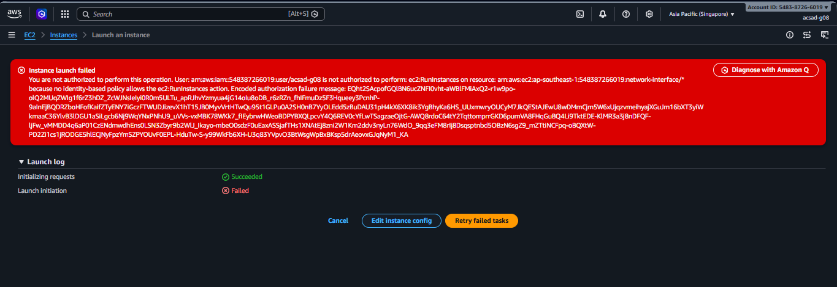
Instance launch failed
You are not authorized to perform this operation. User: arn:aws:iam::548387266019:user/acsad-g08 is not authorized to perform: ec2:RunInstances on resource: arn:aws:ec2:ap-southeast-1:548387266019:network-interface/* because no identity-based policy allows the ec2:RunInstances action. Encoded authorization failure message: EQht2SAcpofGQlBN6ucZNFI0vht-aWBlFMiAxQ2-r1w9po-olQ2MUqZWIg1f6rZ3hDZ_ZcWJNsIeIyi0R0m5ULTu_apRJhvYzmyua4jG14oIu8oDB_r6zRZn_fhIFmuDz5F3Hqueey3PcnhP-9aInEjBQDRZboHFofKaifZTyENY7iGczFTWUDJizevX1hT15JB0MyvVrtHTwQu95t1GLPu0A2SH0nB7YyOLEdd5zBuDAU31pH4kX6XK8ik3YgBhyKa6HS_UUxmwryOUCyM7JkQEStAJEwU8wDMmCjm5W6xUjqzvmeihyajXGuJm16bXT3yiWkmaaC36YlvB3lDGU1aSiLgcb6Nj9WqYNxPNhU9_uVVs-vxMBK78WKk7_fIEybrwHWeoBDPYBXQLpcvY4Q6REV0cYfLwTSagzaeOjtG-AWQ8rdoC64tY2TqttomprrGKD6pumVA8FHqGuBQ4Li9TktEDE-KlMR3a3j8nDFQF-ljFw_vMMDD4q6aP01CzENdmwdhEns0LSN3Zbyr9b2WlJ_Ikayo-mbeO0sdzF0uEaxASSjafTHs1XNAtEj8zni2W1Km2ddv3nyLn76WdO_9qq3eFM8rIj8Dsqsptnbd5OBzN6sgZ9_mZTtiNCFpq-oBQXtW-PD2Zi1cs1jRODGE5hlECjNyFpzYmSZPYOUvF0EPL-HduTw-S-y99WkFb6XH-U3q83YVpvO3BtWsgWpBxBKsp5drAeovxGJqNyM1_KA
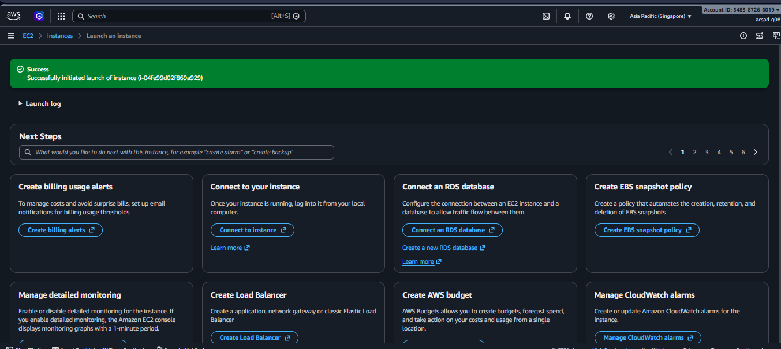
Open the instance list. Wait until Instance state is Running. Write the time in your submission.md The 90-minute cutoff clock starts now. 8 MIN ATA

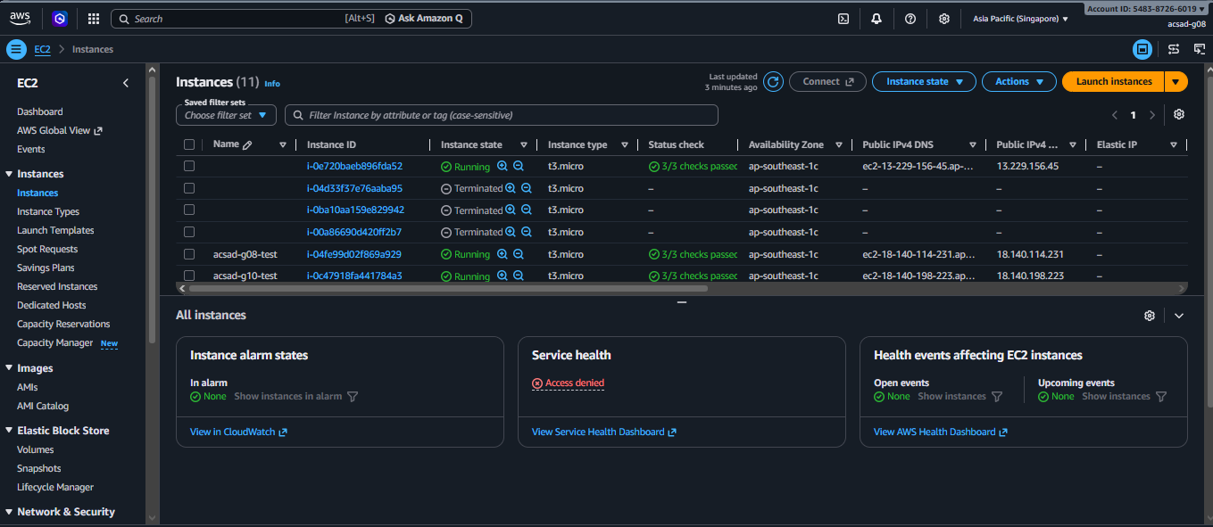

PART E
- Launch a second instance as in Part D, but choose instance type t3.small. Copy the error. It says explicit deny in a permissions boundary.

You are not authorized to perform this operation. User: arn:aws:iam::548387266019:user/acsad-g08 is not authorized to perform: ec2:RunInstances on resource: arn:aws:ec2:ap-southeast-1:548387266019:instance/* with an explicit deny in a permissions boundary: arn:aws:iam::548387266019:policy/umak-lab-boundary. Encoded authorization failure message: XMIVYxeCGa_esY83LmdAsjWd1A8v69z7Yl76B4U_bl4VLmDYRZat5lBKQA1WSboT8NUBAXalS1fqMuiPwa-cHwpTxWQUsZaPb9rDgf5-NEX3IhIPz2J2TkOdJUrpRXrKtA0wXGFWuFLuMtA0gWm5gCKImhfXAhhD8SnFiiTHjc2vwIZN1V7MDgrFO9TsIqjPgfc7VUYL0ttdzIeNtu3snknXCQC0iDor_pwY64mnnAoPmE6xbFy1NRnNWMcZIXKx_oVQgCZfbXRPskf91hESC60L1cKAVA3YUMFetHZM4aB1lPDqbYlbmauNdbhVDf_r4A0UJUp21nenOuZC42P68ApilRGat1M5TIIiptM2dkY7CVJ1fi2-fQHeh0jM42N0ArVLdp-3DK_zWknc6fiP4LAwOe7YL8dHNcSNOiUFbwn6Qi-GGnYNGp2Z_u071j4-YcuOMXd9mAZrG3ysDuHKWsF6eaDhzAMBArf_NFHc8xlo6O9HOHVnI78S64vDnt-uqyrLIS0ONMb6lgwdgsL3WtUcxdqowVvsjAxXZS0AfEg8GTIPuTXXZww6dlucaVPcIGvz72Q08oXLUrIewWmnHoyqU2NiKA_HzBxOUEyFSEQcgnstdCv4fCJMIPgWaZIeEb4TW9m_5F0214hZLkLkNwoFNBpBMi5CULV-z9Ue6s3J235Wg3lwAtmPjFjtMUe_sIww8Gm5TD41vv4XKHzA6h9amTIqKXW7GcmzeOh2d8igFPF4Zf_LsBZrd8O_XDS6OLluohEcDDYzN0B0q-_VQemO5TjtZglO13zc-QcR25x3lLFqJtGG9Xjipc32xNes6FDxpl9QUkxc52lh59AwtVkDERQyesr-Ue9o26WjCSKtU5llexwgJTw7SFuwbe2WSdtsabTxz2gQqyEgPO56vGsSfA4wNtxbnGdcnS1IFp78oBLRtLfPqWGgC1G1RX5Deg
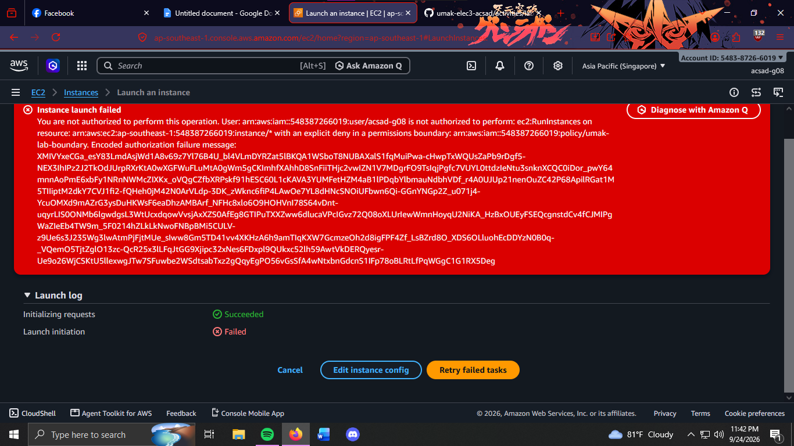

2.
Open IAM, then Policies, then Create policy, then the JSON editor. Paste this policy:
Name it <user>-too-wide. Create it. Attach it to your user as in Part D steps 1 to 3.

3. Wait 15 seconds. Try the t3.small launch again. It is still denied.
4. Switch the Region to Asia Pacific (Tokyo). Try to launch any instance. Because the permissions boundary denies actions outside Singapore, the console immediately displays red error markers for the AMI and VPC selectors; copy the text from these error markers into submission.md. Switch back to Singapore.

5. Open your user, then the Permissions tab. Select <user>-too-wide, click Remove, and confirm. Then open IAM, Policies, select <user>-too-wide, and choose Delete.
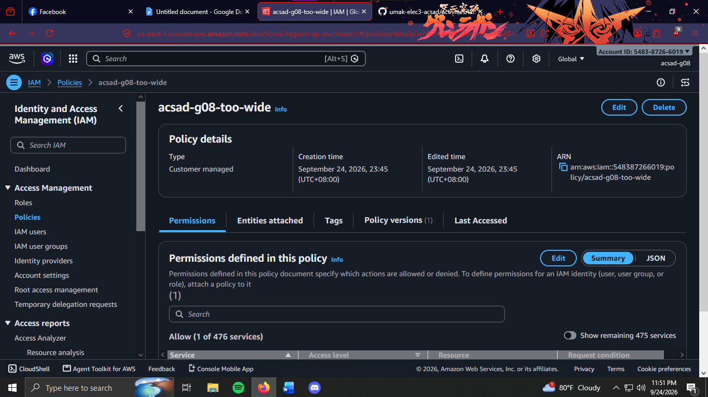
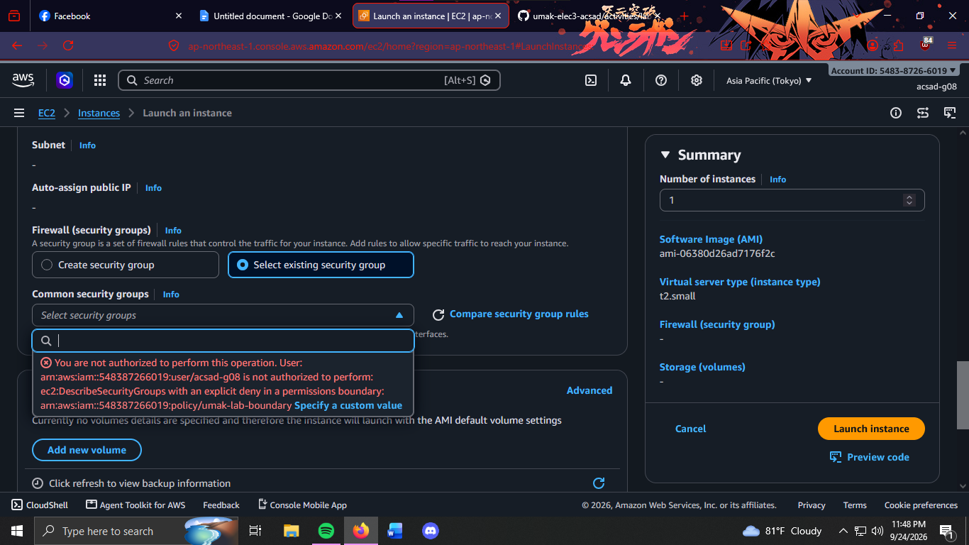
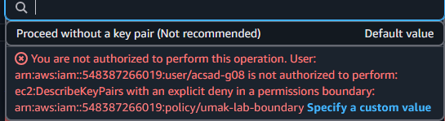

6. Open EC2, Instances. Select the instance from Part D. Choose Instance state, then Terminate (delete) instance. This works because the instance carries your team tag.
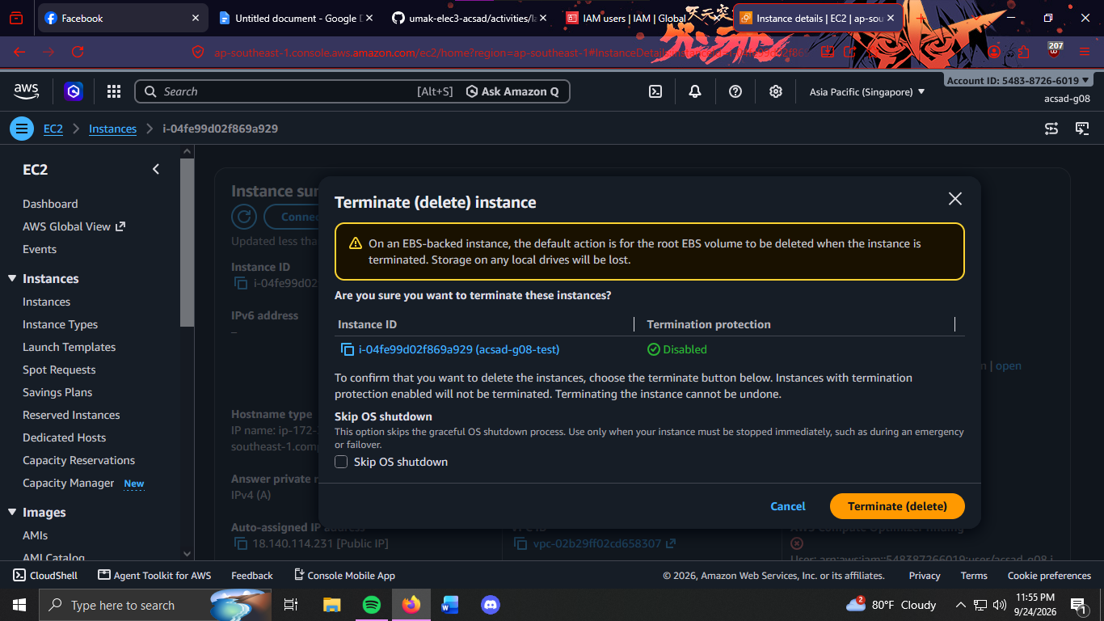

Part F: Questions and Evidence
1. Which action did the Part B error name?
ec2:RunInstances
2. In your policy, which condition limits ec2:RunInstances?
The condition "ec2:InstanceType": "t3.micro" limits ec2:RunInstances to only allow t3.micro instances.
3. After you attached ec2:* on * , why was t3.small still denied? Name the boundary statement.
The t3.small launch was still denied because the permissions boundary explicitly denies instance types other than t3.micro. The boundary statement is "DenyAnyInstanceTypeButT3Micro."
4. Why is ec2:* on * a poor policy even with a boundary?
The policy gives permission to perform all EC2 actions on all resources, which violates the principle of least privilege. A permissions boundary limits some actions, but the policy is still unnecessarily broad.
5. In two sentences: what does the boundary control that your policy cannot?
The permissions boundary sets the maximum permissions that the IAM user can have, including restrictions on instance types, regions, and resource ownership. Even if an attached policy allows an action, the boundary can still prevent that action from being performed.

